The University of Nottingham

DEPARTMENT OF MECHANICAL, MATERIALS AND MANUFACTURING ENGINEERING

A LEVEL 3 MODULE, SPRING SEMESTER 2019-2020

THERMOFLUIDS 3

Time allowed TWO Hours

All solutions to this assessment should be submitted as a single file.
Written answers should be typed; handwritten calculations and free drawn diagrams can be inserted as figures into the solutions document.

Answer ALL questions from Section A and Section B

ADDITIONAL MATERIAL: Thermodynamic Properties of Fluids & other data (in S.I Units) are not required
Formula sheet
(Note that an Enthalpy Entropy chart for steam is not required in this exam.)

[Total marks available: 130]

Section A
Answer ALL questions in this section

- A battery is embedded in a block of resin ($k=0.32 W/mK$) as shown in Figure Q1. Using the values given, what will be the maximum heat flow that you can have from the battery to the surface of the resin if the battery cannot go above $T_{1}=$45 °C and assuming that the surface of the resin is at the ambient temperature of $T_{2}=$20 °C.

You can use the shape factor $S$equation: $S=\frac{2πL}{\ln\left(1.08\frac{w}{D}\right)}$ [4]
L=70 mm
w=40 mm
w=40 mm
D=10 mm, $T_{1}={45 }^{o}C$
$$T_{2}={20 }^{o}C$$
Figure Q1: Battery embedded in resin

- When there is little change in the viscosity of fluids with temperature, the overall forced convection across a sphere can be shown to have the following relationship between the Nusselt number, Reynolds number and Prandtl number:
$$\overline{Nu_{L}}=2+\left(0.4 Re_{D}^{\frac{1}{2}}+0.06 Re_{D}^{\frac{2}{3}}\right)Pr^{0.4}, 3.5<Re_{D}<7.6×{10}^{4}, 0.71<Pr<380$$
Using your knowledge of the analogy between heat transfer and mass transfer, rewrite this equation in terms of the overall Sherwood number, the Schmidt number and the Reynolds number to represent the mass transfer from the cylinder. This can be used to simulate a droplet that is evaporating. [4]

- Explain, with the aid of a well-drawn diagram, why there is a contact resistance between two solids in contact. The explanation should include how the smoothness of the surface can affect this contact resistance and how the use of thermal gels can improve the heat transfer performance. Limit your answer to 400 words and a clear, well annotated diagram. [8]

- Water flowing at 0.5 m/s through a smooth pipe is turbulent. The diameter of the pipe is $D$=30 mm and the surface of the pipe is at 100 °C. Using the Dittus-Boelter equation, estimate the heat transfer coefficient if the water is at an average temperature of 10°C.

Dittus-Boelter equation is:
$\overline{Nu_{D}}=0.023Re_{D}^{0.8}Pr^{n}$, n=0.4 for heating and n=0.3 for cooling of fluid. [10]
- Explain with the aid of a well-drawn diagram, the concept of irradiation, radiosity, emission and diffuse reflections. Limit your answer to 400 words and a clear, well annotated diagram. [8]

- Write the equation for the equilibrium constant for the following reaction in terms of partial pressures: H₂O + CO ⇋ H₂ + CO₂ [4]

- Discuss three ways in which the efficiency may be increased for a simple Rankine cycle steam plant operating with a final steam temperature of 450 °C and pressure of 80 bar. In each case give at least one advantage and one disadvantage. (Do not write more than about 200 words in answer to this question)
[8]

- In a gas turbine the compressor takes in air at a pressure of 1.05 bar and temperature of 15°C. The compressor outlet pressure is 10.5 bar. The turbine entry temperature is 1200°C and the inlet pressure is 10.0 bar. The turbine exhaust pressure is 1.10 bar. The polytropic efficiency of both the compressor and turbine is 90%. Calculate the compressor outlet temperature and the turbine outlet temperature. Assume the working fluid is air throughout both compressor and turbine with the ratio of the specific heat capacities (γ) = 1.4. [8]

9. State the meaning of 90° type inflow radial turbine, stating the implications for velocity at entry and exit and why this configuration is chosen. Sketch a side view of the cross section of a radial inflow turbine labelling the scroll and rotor and indicating the direction of flow on the diagram. Your answer must be limited to 100 words, any further words will not be assessed [5]

10. Figure Q10 shows the velocity vectors concerned with an oblique shock formed by a supersonic flow approaching an inclined wall. State the effect of the shock on the entering velocity. The direction of the resultant, and the meaning of weak shock and strong shock should be addressed. Your answer must be limited to 100 words, any further words will not be assessed. [7]

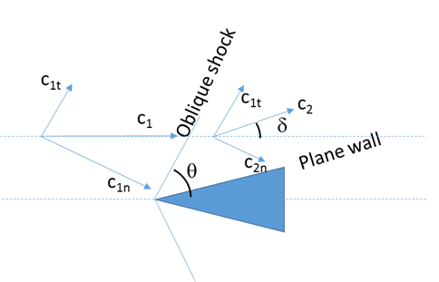
Figure Q10

Section B
Answer ALL question in this section

11. (a) A turbine stage is to be designed with a flow coefficient of 0.6, a reaction of 50% and a stage loading of 3. Use the given formulae to derive an expression for the relative velocity angles at entry and exit. Calculate the entry and exit relative flow angles using the data given and sketch the velocity triangles of the rotor inlet and outlet stating any conditions that you use to determine the shape of the triangles. [9]

(b) A flow of air at Mach 2.5 expands around a corner of angle 20°. Use the Prandtl-Meyer chart to determine the exit Mach number. Make a sketch of the chart in your answer book to indicate the angle change and Mach number change and briefly explain the principle of the chart making clear why it starts at Mach 1. Your answer must be limited to 150 words, any further words will not be assessed. [6]

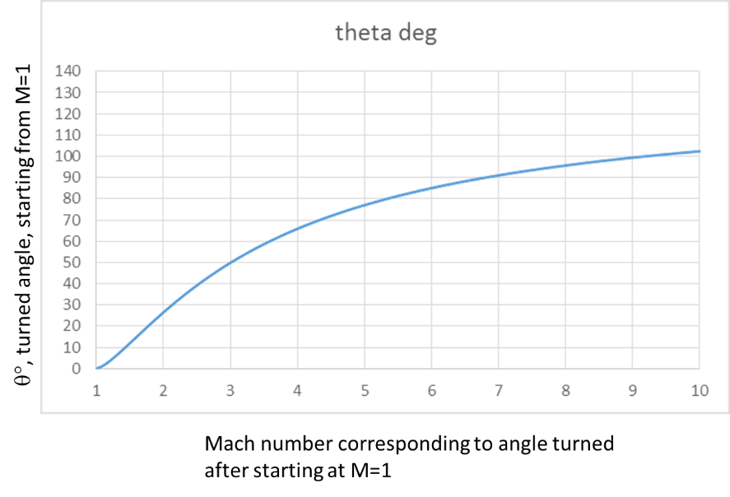
Figure Q.11a

Continued on next page

(c) A hot plate at 100 °C is cooled by attaching 30 mm long and 2.5 mm diameter aluminium pin fins ($k=237 W/mK)$ to the surface to improve the cooling rate. There are 100 pins in a 10 x 10 array on the plate, and the plate is 50 mm x 50 mm in size. Assume that the surrounding medium is at 30 °C and that the heat transfer coefficient from all surfaces is $35 W/m^{2}K$. The rate of heat transfer from the flat plate without fins is 6.125 W. The interfin area between the pin fins is $A_{if}=2.01×{10}^{-3}m^{2}$. The surface area of one pin fin is $A_{fin}=2.36×{10}^{-4}m^{2}$.

i) What is the value of the shape factor $m$ for this design of pin fins? [5]

ii) What is the efficiency of the fins assuming that the adiabatic tip assumption is valid? [3]

iii) What will be the rate of heat transfer from the complete heat sink including the remaining base plate after the pin fins are attached? [5]

iv) What is the effectiveness for the entire heat sink including the base plate? [2]

Efficiency in adiabatic tip approximation is given by:
$$η=\frac{\tanh\left(m L_{c}\right)}{m\left(L_{c}\right)}$$

12. (a) A furnace is shaped as a long equilateral triangular duct as shown in figure Q12a. The width of each side of the furnace is 1 m. The base surface has an emissivity of 0.7 and is maintained at a uniform temperature of 600K. The heated left side surface closely approximates a blackbody at 1000K. The right side is well insulated.

i) Identify the values of each thermal resistance and both the black body emissions ($E_{b1}$ and $E_{b2}$) in figure Q12a. [12]

ii) Determine the rate that heat must be supplied to the heated side per unit length of the duct in order to maintain these conditions. [3]
Side 1: $ϵ_{1}=0.7$
$$T_{1}=600K$$
Side 2: black
$$T_{2}=1000K$$
Side 3: insulated
$${\dot{Q}}_{1}$$
$${{\dot{Q}}_{2}=-\dot{Q}}_{1}$$
$$J_{2}=E_{b2}$$
$$E_{b1}$$
$$R_{1}$$
$$R_{2}$$
$$R_{12}$$
$$R_{23}$$
$$R_{13}$$
$J_{3}=E_{b3}$
$${\dot{Q}}_{3}=0$$
$$J_{2}$$
$$J_{1}$$
Figure Q12a
Continued on next page

(b) A heat pump as shown in Figure Q12b is used to provide heating for a building. The outside environment air temperature is 5°C and the temperature inside the building is 21°C. The heat pump operates with working fluid R134a. The saturation temperature in the evaporator is 0°C and the saturation temperature in the condenser is 40°C. The electric motor has an efficiency of 90%.
2
3
4
1
Compressor
Evaporator
Condenser
Throttle
Valve
Electric
Motor
Heat input from environment
Heat output to building

Figure Q12b

If the rate of heat input to the building is 25 kW, calculate:

- the mass flow rate of the working fluid (R-134a); [2]

ii) the rate of exergy input to the building needed to maintain the internal temperature of 21°C; [3]

iii) the Coefficient of Performance of the heat pump and the overall Rational Efficiency of the heat pump in providing heat for the building; [3]

iv) the rate of irreversibility in the compressor, motor, evaporator, condenser and throttle. [4]

v) Discuss the reasons for the irreversibilities in the evaporator and condenser and how these may be reduced. (Write no more than about 100 words) [3]

The specific enthalpy and specific exergy at each point around the cycle is as shown below:

 |  |  |  | Specific | Specific
 | Pressure | State | Temperature | Enthalpy | Exergy
 | [bar] |  | [°C] | [kJ/kg] | [kJ/kg]
1. | 2.928 | Dry Sat vapour | 0.0 | 398.43 | 20.09
2. | 10.163 | S/H vapour | 60.0 | 441.32 | 48.41
3. | 10.163 | Sat liquid | 40.0 | 256.38 | 27.07
4. | 2.928 | Wet vapour | 0.0 | 256.38 | 22.62

END

